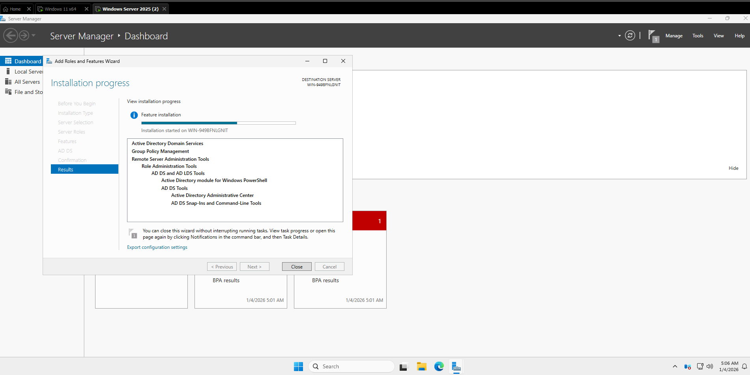
Installing Active Directory Domain Services
Active Directory Domain Services were installed so the server could function as a Domain Controller. This allows for centralized management of users and devices within the network.
PowerShell command used:
Install-WindowsFeature -Name AD-Domain-Services -IncludeManagementTools
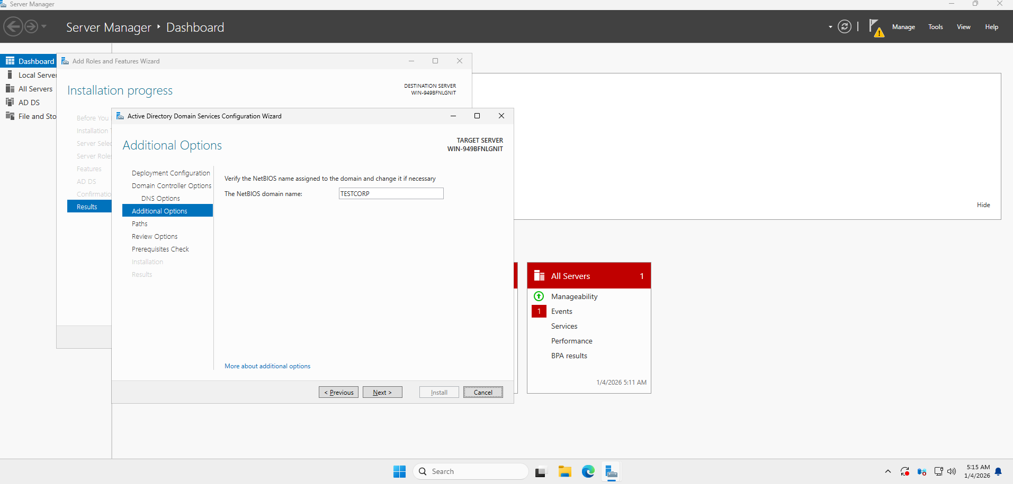
Promoting the Server to a Domain Controller
After installing Active Directory Domain Services, the server was promoted to a Domain Controller by creating a new domain and forest.
PowerShell command used:
Install-ADDSForest -DomainName "testcorp.local" -DomainNetbiosName "EXAMPLE" -SafeModeAdministratorPassword (ConvertTo-SecureString "PASSWORD" -AsPlainText -Force) -InstallDNS
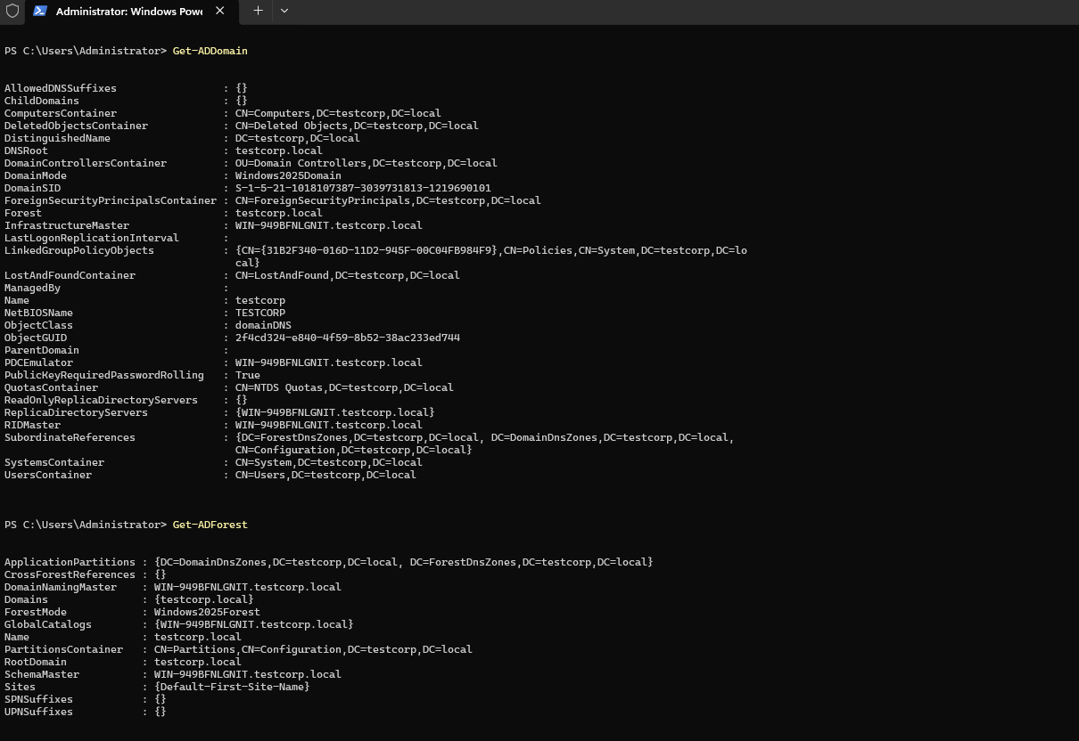
Verification
The domain and forest configuration information was verified and confirmed to be accessible, indicating that the Domain Controller setup was completed successfully.
configuring a dc

